Read ME:-

Test1 : - Not able to find the steps given in test case on website, so this script is not complete, still I coded till I found steps on website.

Test 2 : Complete and passing

Test 3 : Completed but it includes CAPTCHA which cannot be automated and should not be automated as directed by Selenium org

#############################################################################

Steps to run tests

1. Unzip the Test Framework and build, all dependencies should be downloaded automatically by NuGet packages. If not Restore NuGet Packages by right clicking on solution and click on

Restore NuGet Packages.

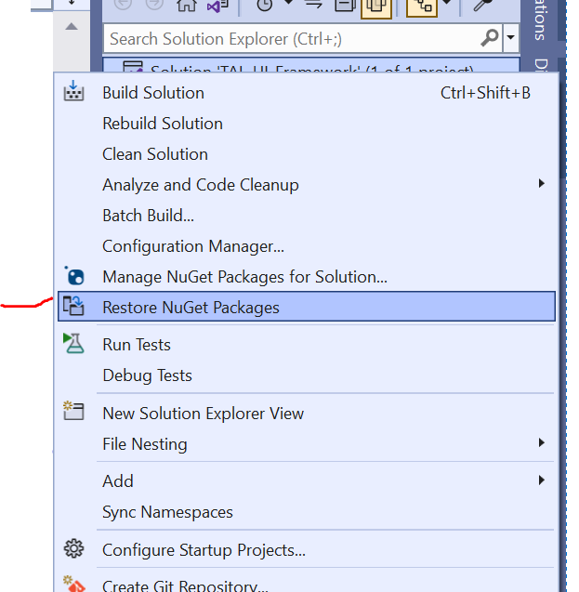

1. Install spec flow extension on Visual studio from Extensions – Manage Extensions
2. To run the test cases Build the solution and right click on The Tal_UI_Framwork a in test Explorer and click on run button to run all tests in 1 go , or run 1 by 1 by selection individual test case

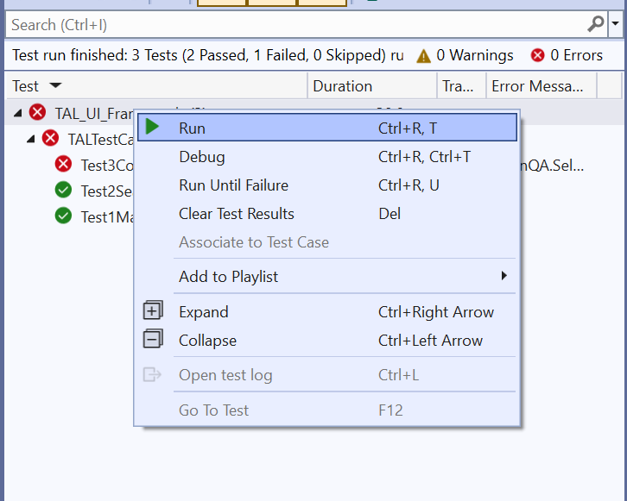

1. Extent Reports are added to the framework to see the run result

Right click on the Results folder in Solution Explorer and click on Open folder in file location

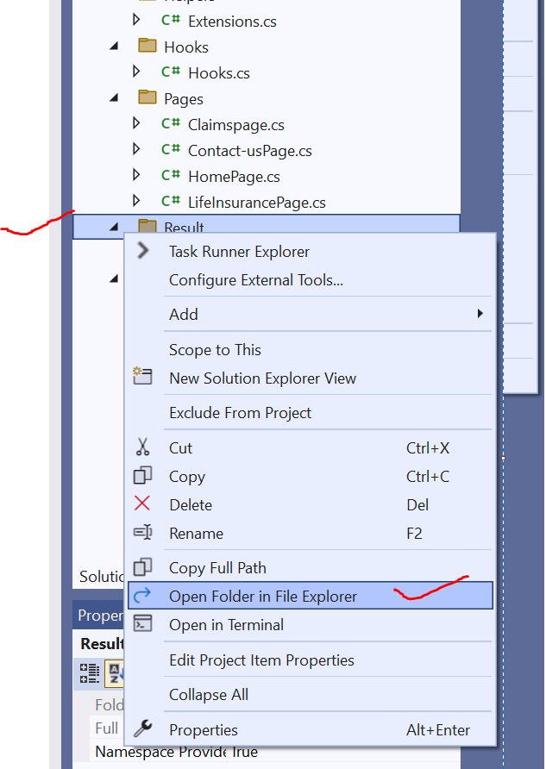

Right click on the index.html and select Open with (Select a browser ex. Chrome )

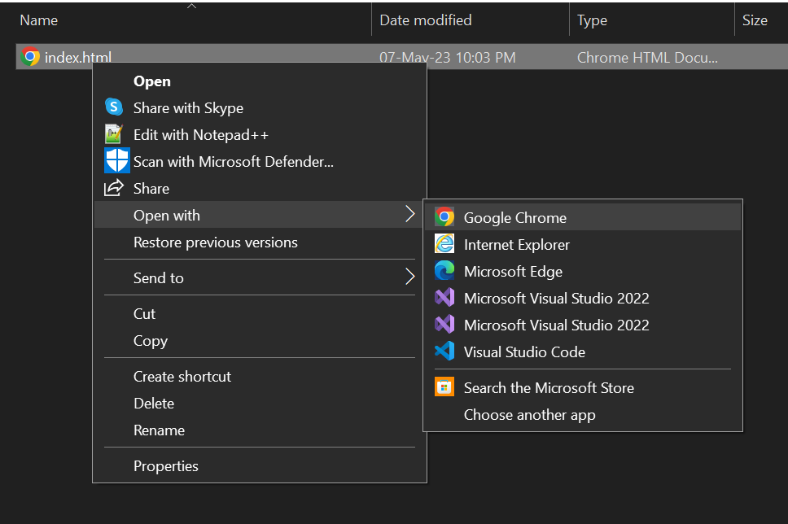

And you will get the report of the last run

